

SEMESTER TWO EXAM
YEAR: 10
SUBJECT: Science

TIME: 120 minutes
QUESTIONS: 35 Multiple Choice Worth 35 marks.
10 Short Answer Worth 50 marks.
1 Extended Answer Worth 15 marks.
TOTAL MARKS: 100

DO NOT WRITE ON OR MARK THIS PAPER
IMPORTANT FORMULAE

v_{av} = d/t or v_{av} = s/t.

v _{av} = u + v
2

a = v – u
t

v = u + at

Work = F x d

E_{p} = mgh

E_{k} = ½ mv²

F = ma

W = mg

Acceleration due to gravity on Earth: g = 9.8 ms⁻² .
SECTION ONE—MULTIPLE CHOICE (30 marks)

This section has 35 questions. Answer all questions on the separate Multiple-choice Answer Sheet provided. Each question is worth 1 mark.

Question 1
Which of the following is NOT an SI unit?

- ms⁻².
- s.
- kms⁻¹.
- kgm⁻¹.

Question 2
A train travels at a speed of 18 ms-1. This is equivalent to a speed of:

- 5 kmh⁻¹.
- 64.8 kmh⁻¹.
- 64 800 kmh⁻¹.
- 0.005 kmh⁻¹.

Question 3
Inertia can be defined as:

- The amount of matter in an object.
- A tendency of an object to resist a change in its motion.
- The force of gravity on an object.
- When a force makes something move.

Question 4
Which one of the following statements about friction is INCORRECT?

- Friction operates in the same direction as a moving object.
- Friction is a contact force.
- Friction between two moving objects produces heat.
- Without friction we could not grip an object or walk.

Question 5
A 90 N force is applied to a 65 kg mass. The mass will accelerate at approximately:

- 7.2 ms⁻².
- 1.1 ms⁻².
- 1.4 ms⁻².
- 5.9 ms⁻².

Question 6

A skydiver glides to the ground at a steady speed of 7 metres per second. Which statement below best describes what is happening?

- The upward force of air resistance acting on the skydiver is smaller than the downward weight force that is acting.
- The upward force of air resistance acting on the skydiver is larger than the size of the downward weight force.
- The upward force of air resistance balances the downward force of gravity acting on the skydiver.
- The weight force that acts on the skydiver is larger than the upwards force of air resistance.

Question 7

Two forces stretch a cable within a structure. Which of the following statements best describes the cable?

The cable is in compression.

The cable is in tension.

The cable is being stretched by gravity.

The cable is unbalanced.

Question 8
Sandstone is a building material that is strong under:

- compression only
- tension only
- both compression and tension
- all forces

Question 9
Which of the following best describes a lintel?

- Lintels are beams commonly used over doors and windows.
- Lintels are used to support the walls of Gothic arches.
- Lintels are domes.
- Lintels are made up of steel triangles.
Question 10
When standing, your legs are in:

- compression
- tension
- failure
- friction

Question 11
Which of the following is not acceleration?
- Getting faster.
- Staying the same velocity.
- Changing direction but not speed.
- Slowing down.

Question 12
If a ball of mass 400g accelerates at a rate of 300ms⁻², it must have been acted on by an unbalanced force of:
- 120 N.
- 120000 N.
- 0.75 N.
- 75 N.

Question 13
The point where your weight would appear to be concentrated in a single point, is called:

- the balance centre.
- the weight point.
- the buoyancy centre.
- the centre of mass.

Question 14
In experiments, a Ticker Tape Timer was used to give an accurate measurement of:

- distance
- time
- speed
- acceleration

Question 15
A fee falling body on Earth will have an acceleration of:

- 5.5 ms⁻¹.
- 9.8 ms⁻¹ .
- 9.8 ms⁻².
- 5.5 ms⁻².

Question 16
A trolley with an initial velocity of 5 ms⁻¹ attained a velocity of 25 ms⁻¹ in 4 seconds. The acceleration of the trolley was:

- 25 ms⁻².
- 10 ms⁻².
- 5 ms⁻².
- 4 ms⁻².

Question 17
A 12 kg object was allowed to free fall from rest. What was its velocity after 15 seconds?

- 15 ms⁻¹ .
- 110 ms⁻¹ .
- 147 ms⁻¹ .
- 47 ms⁻¹ .

Question 18
A body is subject to a deceleration of 9.0 ms⁻². The decrease in velocity per second is:

- 3.0 ms⁻¹ .
- 9.0 ms⁻¹ .
- -3.0 ms⁻¹ .
- 81.0 ms⁻¹ .

Question 19
A car was uniformly accelerated from rest at 7 ms⁻². How long did it take to reach a velocity of 56 ms⁻¹?

- 7.0 s .
- 8.0 s .
- 14.0 s.
- 56.0 s .

Question 20
Which of the following correctly describes the motion of a body free falling from rest?

- The average velocity during the first second is 5.0 ms⁻¹ .
- During each second the body falls 9.8 metres .
- The acceleration changes by 9.8 ms⁻² every second.
- The body falls 9.8 metres during the first second.

Question 21
Identify the best description of what global warming is.

a) Periods of global warming occur between periods of glaciations.
b) Greenhouse gases in the atmosphere cause global warming.
c) Global warming began after the Industrial Revolution.
d) During periods of global warming sea levels fall exposing more land.

Question 22
Describe sustainable ecosystem.

- Ecosystems that provide many different resources for humans.
- Stable ecosystems that have survived unchanged for thousands of years.
- Diverse ecosystems that provide for the needs of the organisms that live there.
- Ecosystems that survive without any input from humans.

Question 23
Identify Earth’s largest and oldest long-term store of carbon.

- Rainforest trees.
- Calcium carbonate.
- Fossil fuels.
- Carbon dioxide.

Question 24
Compare the actions of nitrogen fixing bacteria and denitrifying bacteria in the nitrogen cycle.

- Nitrogen fixing bacteria absorb nitrogen from the air. Denitrifying bacteria use nitrogen compounds in living things to obtain nitrogen.
- Nitrogen fixing bacteria convert nitrogen into ammonia and then into nitrites. Denitrifying bacteria convert nitrites into nitrates.
- Nitrogen fixing bacteria absorb nitrogen from air and convert it into nitrates. Denitrifying bacteria convert nitrates into gaseous nitrogen.
- Nitrogen fixing bacteria release the nitrogen stored in tissues of living things. Denitrifying bacteria absorb nitrogen from the air

Question 25
Which statement does NOT describe greenhouse gases or the effect they have:

- Nitrogen and oxygen are greenhouse gases that absorb the short-wave radiation coming into the Earth’s atmosphere from the sun.
- Water vapour and carbon dioxide in the atmosphere have no effect on the short-wave radiation coming into the Earth’s atmosphere from the sun.
- Greenhouse gases trap heat close to the surface of the Earth keeping it warmer than it would be without those gases.
- Greenhouse gases are mainly composed of carbon dioxide and methane and prevent heat being reflected back into space.

Question 26
Examine the diagram of the water cycle. Identify the processes occurring at 1, 2, 3, 4 and 5 in this order.

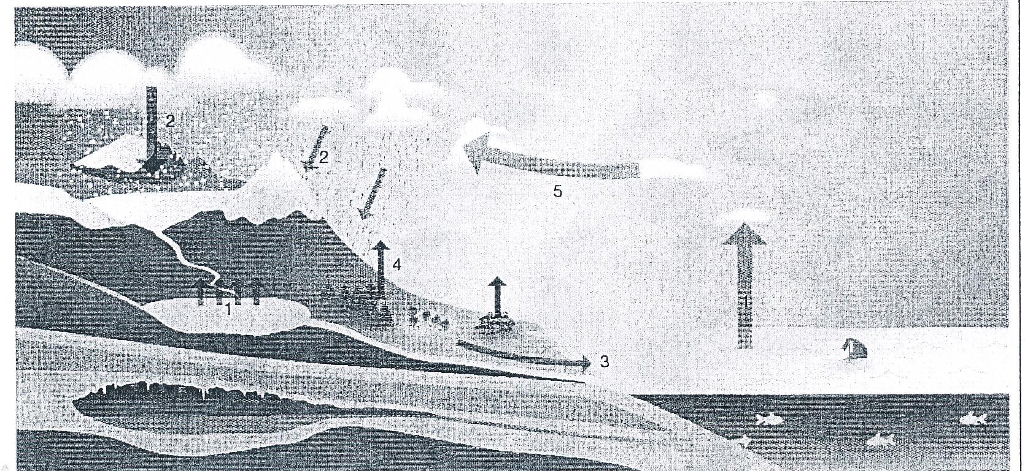

- Evaporation; precipitation; runoff; condensation; transpiration.
- Precipitation; evaporation; transpiration; condensation; runoff.
- Evaporation, precipitation, runoff; transpiration; condensation.
- Transpiration; condensation; runoff; precipitation; evaporation.

Question 27
Identify the list that contains some of the main causes of ocean currents.

- Temperature; variations in salinity; revolution of the Earth around the Sun.
- Variation in salinity; rotation of the Earth; position of the continents.
- Wind; position of the continents; gravitational pull of the Sun and Moon.
- Gravitational pull of the Sun and the Moon, temperature; rotation of the Earth.

Question 28
Identify the statement that does NOT describe an effect of Antarctic ice.

- Ice acts as an insulator reducing the amount of heat that moves from water into the atmospheres.
- As ice freezes salt remains in the ocean increasing the salinity and density of the water.
- Cold dense water at the Antarctic takes carbon dioxide from the atmosphere and into the deep ocean currents.
- Areas of ice reflect more of the Sun’s rays than forests. This has the effect of increasing the Earth’s average temperatures.

Question 29
What is the UNLIKELY effect of Global Warming?

- Plants found on mountain tops will extend their range towards the slopes and valleys.
- Winters become shorter in many places so that the growing season is increased.
- Melting ice causes sea levels to rise inundating low lying areas.
- Animals found in warm seas will extend their rang away from the equator towards the poles.

Question 30
The El Nino Ocean current exists in which ocean?

- The Indian Ocean.
- The Southern Ocean.
- The Pacific Ocean.
- The Atlantic Ocean.

Question 31
What type of bridge is shown in the diagram below?
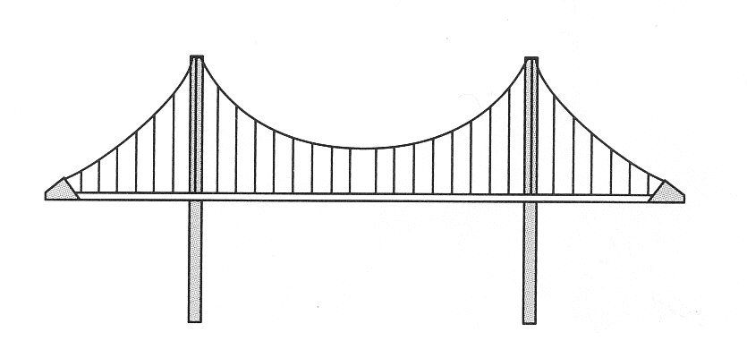

- A Bowstring Arch bridge.
- A Cable-stayed bridge.
- A Suspension bridge.
- A Cantilever bridge.

Question 32
What type of structure is shown in the following diagram?
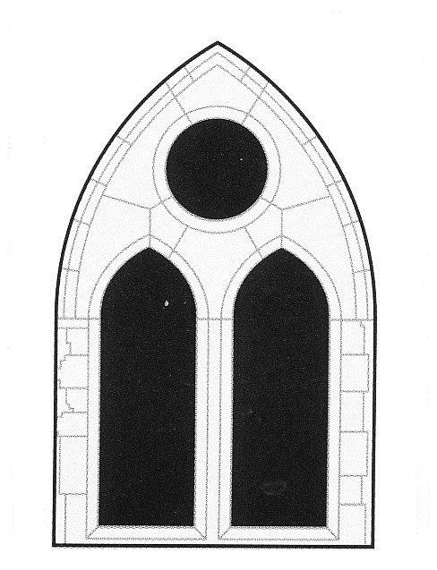
- A Lintel.
- A Roman Arch.
- A Dome.
- A Gothic Arch.

Question 33
A cable was placed under tension until just before it broke. Which of the following diagrams best shows the cable before it broke.

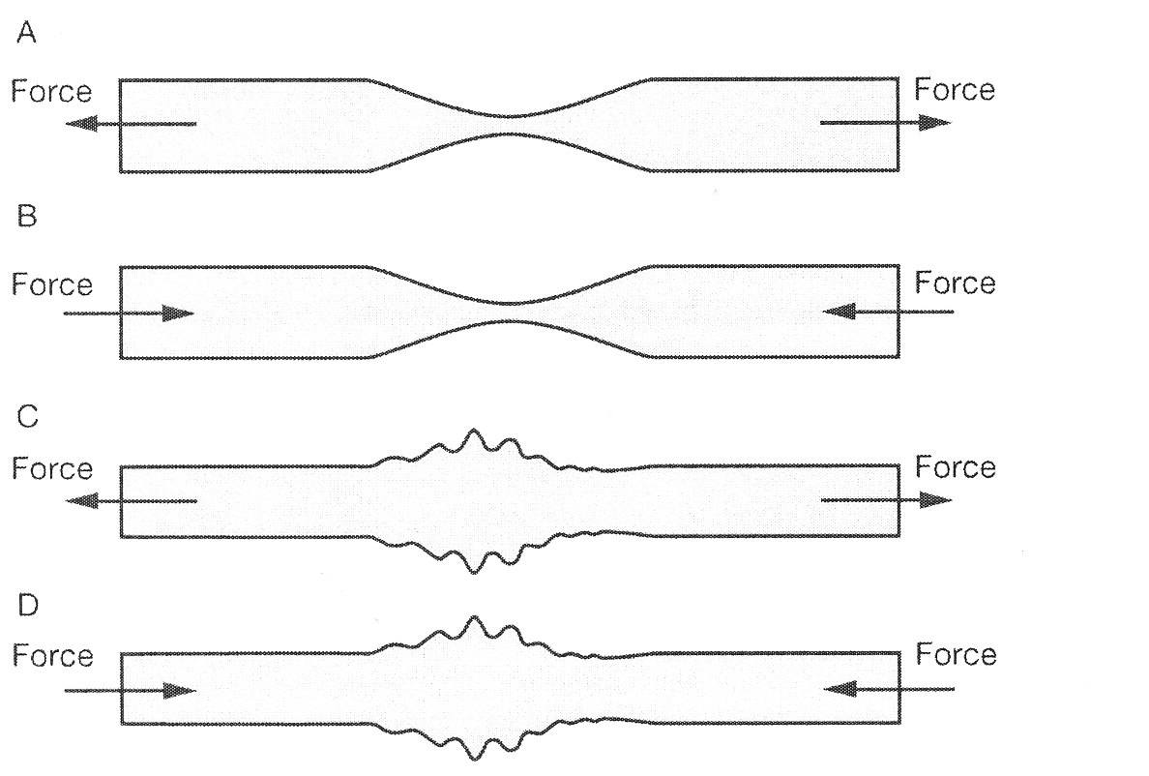

Question 34
A racehorse runs a race that starts and finishes at the same point. If the race was 1000 metres, what was the displacement of the horse when it finished?

- 1000 metres.
- 500 metres.
- 10 metres.
- 0 metres.

Question 35
Which of the following stick people would be unstable and most likely to topple over?

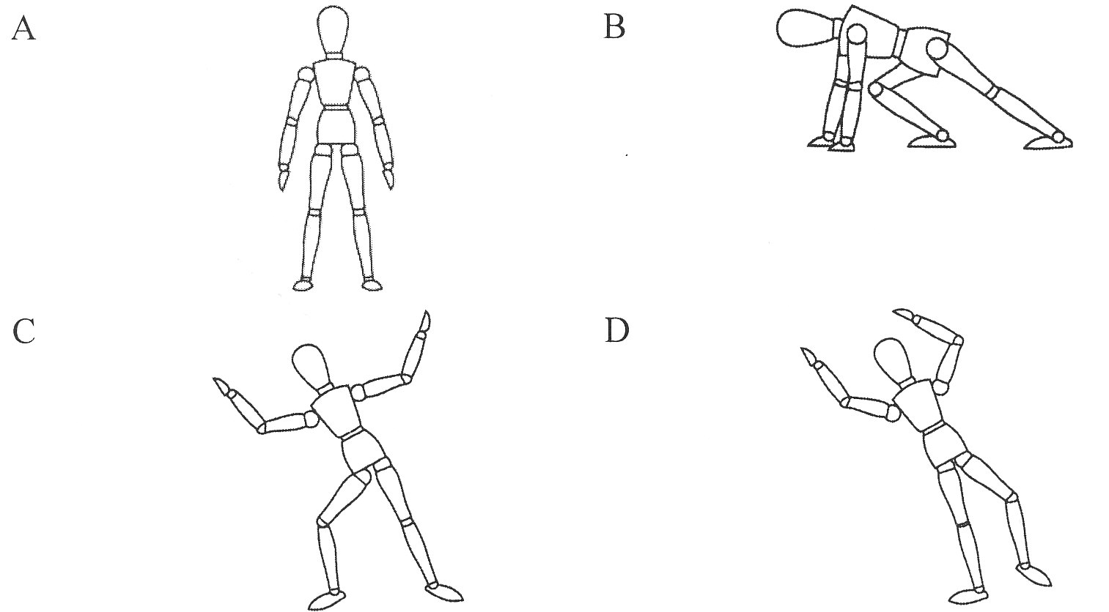

END OF MULTIPLE CHOICE SECTION
oooOOOooo

SEMESTER TWO EXAM
YEAR: 10
SUBJECT: Science
ANSWER BOOKLET

NAME:

SECTION ONE—MULTIPLE CHOICE (35 marks)

For each question shade the box to indicate your answer. Use only a blue or black pen to shade the boxes. If you make a mistake, place a cross through that square, do not erase or use correction fluid, and shade your new answer. Marks will not be deducted for incorrect answers. No marks will be given if more than one answer is completed for any question.

1 | a | b | c | d |  | 19 | a | b | c | d
2 | a | b | c | d |  | 20 | a | b | c | d
3 | a | b | c | d |  | 21 | a | b | c | d
4 | a | b | c | d |  | 22 | a | b | c | d
5 | a | b | c | d |  | 23 | a | b | c | d
6 | a | b | c | d |  | 24 | a | b | c | d
7 | a | b | c | d |  | 25 | a | b | c | d
8 | a | b | c | d |  | 26 | a | b | c | d
9 | a | b | c | d |  | 27 | a | b | c | d
10 | a | b | c | d |  | 28 | a | b | c | d
11 | a | b | c | d |  | 29 | a | b | c | d
12 | a | b | c | d |  | 30 | a | b | c | d
13 | a | b | c | d |  | 31 | a | b | c | d
14 | a | b | c | d |  | 32 | a | b | c | d
15 | a | b | c | d |  | 33 | a | b | c | d
16 | a | b | c | d |  | 34 | a | b | c | d
17 | a | b | c | d |  | 35 | a | b | c | d
18 | a | b | c | d

SECTION TWO—SHORT ANSWER (50 marks)

This section has ten (10) questions. Answer all questions. Write your answers in the spaces provided.

Question 1
Explain the effect that each of the following would have on the acceleration of an object.

a. The force acting on an object is tripled. (2 marks)

b. The mass of an object is halved, while a constant force is applied. (2 marks)

Question 2.
Calculate the kinetic energy of a bullet of mass 50 grams that leaves a rifle with a velocity of 900 ms⁻¹. (4 marks)

Question 3.
Calculate the work done when:
a. A force of 25 N moves an object through a distance of 8 metres. (2 marks)

b. A 6 kg object is lifted from a height of 20 metres to a height of 25 metres. (4 marks)

Question 4.
A cannonball of mass 5 kg is dropped from a height of 12 metres off cliff.

Calculate:

a. the potential energy of the cannonball before it was dropped. (4 marks)

b. the speed of the cannonball as it reached the ground. (assuming all the potential energy is converted to kinetic energy.) (4 marks)

Question 5.
A school bus slows from 60 kmh⁻¹ to 40 kmh⁻¹ when entering a school zone.

a. Calculate the conversion of these speeds from kmh⁻¹ to ms⁻¹. (1 mark)

b. Given that the change of speed occurred over 8 seconds, calculate the average deceleration of the bus. (2 marks)

Question 6.
Classify the following as situations in which forces are balanced or unbalanced.

a. A motor bike accelerating away from traffic lights. (1 mark)

b. A car travelling at a constant 100 kmh⁻¹ straight down a freeway. (1 mark)

c. A surfer falling off the surfboard. (1 mark)

d. A bird flying into a window and bouncing off. (1 mark)

Question 7.
a. Explain the difference between reinforced concrete and normal unreinforced concrete.
(2 marks)

b. Explain why reinforced concrete is far better than normal unreinforced concrete in structures. (2 marks)

Question 8
Human activities have added extra carbon dioxide to the atmosphere, putting the carbon cycle out of balance. Propose some extra effects from continued increase in levels of atmospheric carbon dioxide. (4 marks)

Question 9
The emission of large amounts of carbon dioxide into the atmosphere by industry, coupled with the clearing of large areas of rainforest, has led to concern about an enhanced greenhouse effect.

a. Explain how the clearing of rainforest contributes to the greenhouse effect. (4 marks)

b. Potential problems associated with the enhanced greenhouse effect have been described. However, scientists suggest that some plant species may benefit. Explain how this may be so. (4 marks)

Question 10
The diagram below represents part of the carbon cycle.

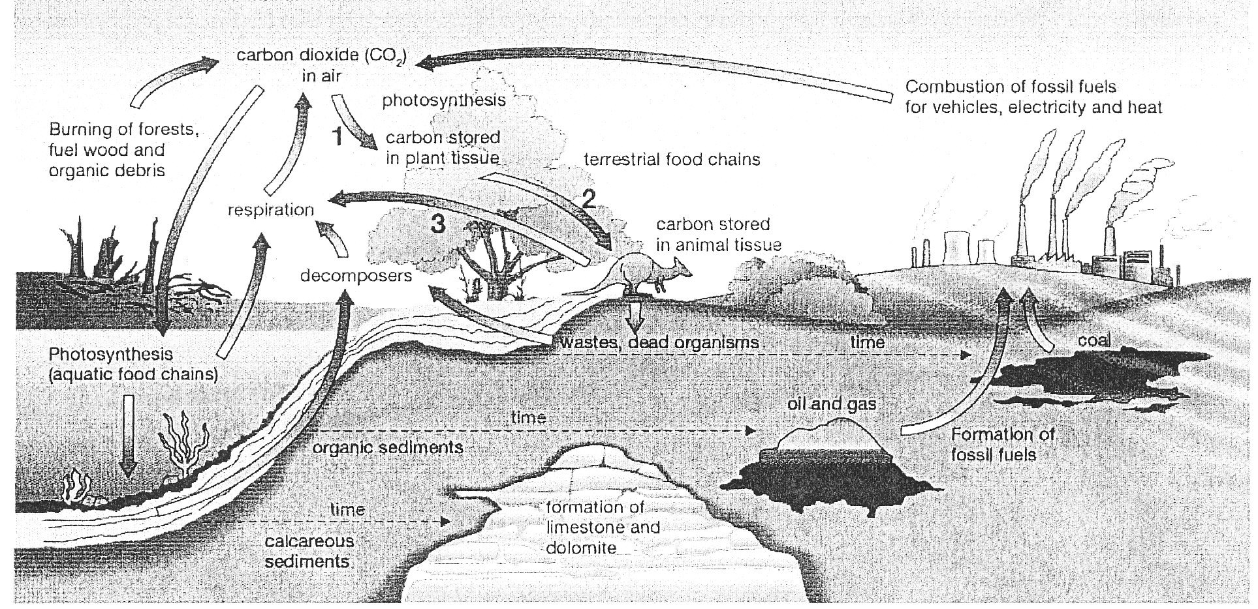

a. Write a description for each of the numbered arrows, 1, 2 and 3, describing what happens at each step. (3 marks)

b. Explain why the recycling of materials is important to the continued functioning of the ecosystems. (2 marks)

END OF SHORT ANSWER SECTION
SECTION THREE—EXTENDED ANSWER (15 marks)
This section contains one (1) question. Complete your answer on the graph paper provided and in the space below using a paragraph structure.

Question 37
The table below shows the speed of a cheetah starting at rest and then at 5 second intervals as it chases its prey. (5 marks)

Time in s | 5 | 10 | 15 | 20 | 25 | 30 | 35 | 40 | 45
Speed in ms⁻¹ | 6 | 14 | 27 | 27 | 27 | 20 | 12 | 3 | 0

Use the information in the table and the graph to;
- Write down the time intervals in which the acceleration of the cheetah was: (3 marks)

i. zero.
ii. positive.
iii. negative.

- Calculate the acceleration of the cheetah between 25 and 40 seconds. (4 marks)

- Calculate the distance run between 0 and 15 seconds. (3 marks)

END OF EXAM

